Postal Life Insurance

Department of Post

Software Requirements Specification (SRS)
  - Lead Management and Illustration System for Customer Portal

INTERNAL APPROVAL FORM

Project Name: Lead Management and Illustration System for Customer Portal
Version: 1.0
Submitted on:
 | Name | Date
Approved By:
Reviewed By:
Prepared By:

VERSION CONTROL LOG
Version | Date | Prepared By | Remarks
1

Table of Contents

1. Executive Summary 4
2. Business Objectives 4
3. Project Scope 4
4. Business Requirements 4
5. Functional Requirements Specification 5
6. Process Flows/ Use Cases/ UML Diagrams 11
7. Appendices 12

1. Executive Summary
This document outlines the business requirements for Lead Management and Illustration System modules in the Customer Portal of Insurance Management System (IMS). It aims to streamline customer acquisition, improve quote accuracy, and ensure compliance with regulatory standards.

2. Business Objectives
The IMS project addresses the need for efficient lead tracking and compliant benefit illustrations. This system will streamline lead tracking, customer engagement, and policy illustration generation for insurance products.

3. Project Scope
The Lead Management and Illustration System will be a module of the Insurance Admin System used by agents, sales managers, and administrators. It will:
- Capture and manage leads from various sources.
- Track lead status and interactions.
- Generate personalized insurance illustrations based on customer inputs.
- Integrate with the Insurance Management System (IMS) for policy creation.

4. Business Requirements

- Lead Management:
FS-LMI-001 | The system shall capture leads from multiple channels (portal, call-centre, walk-ins, referrals, campaigns).
FS-LMI-002 | The system shall allow automatic and manual assignment of leads to agents based on geographical location (PIN code).
FS-LMI-003 | The system shall allow tracking of lead status and follow-up actions.
FS-LMI-004 | The system shall allow reallocation of leads based on updated PIN code mapping or agent availability.

- Illustration System:
FS-LMI-005 | The system shall generate benefit illustrations based on configurable product rules and customer inputs.
FS-LMI-006 | The system shall support generation of new business quotes for insurance products.
FS-LMI-007 | The system shall allow configuration of calculation logic for illustrations by admin users.

5. Functional Requirements Specification

- Lead Management:
  - Lead Capture Page
- Fields:
  - Lead Name (*mandatory)
  - Contact Number (*mandatory)
  - Email ID
  - Address
  - PIN Code (*mandatory)
  - Source (Website, Walk-in, Referral, Call Center, Campaign)
  - Product Interested (*mandatory)
  - Lead Type (New / Existing)
  - Remarks
- Business Rules:
  - Mandatory fields: Name, Contact Number, PIN Code, Product Interested.
  - Duplicate check on Contact Number.
Wireframe for the Lead Capture Page:
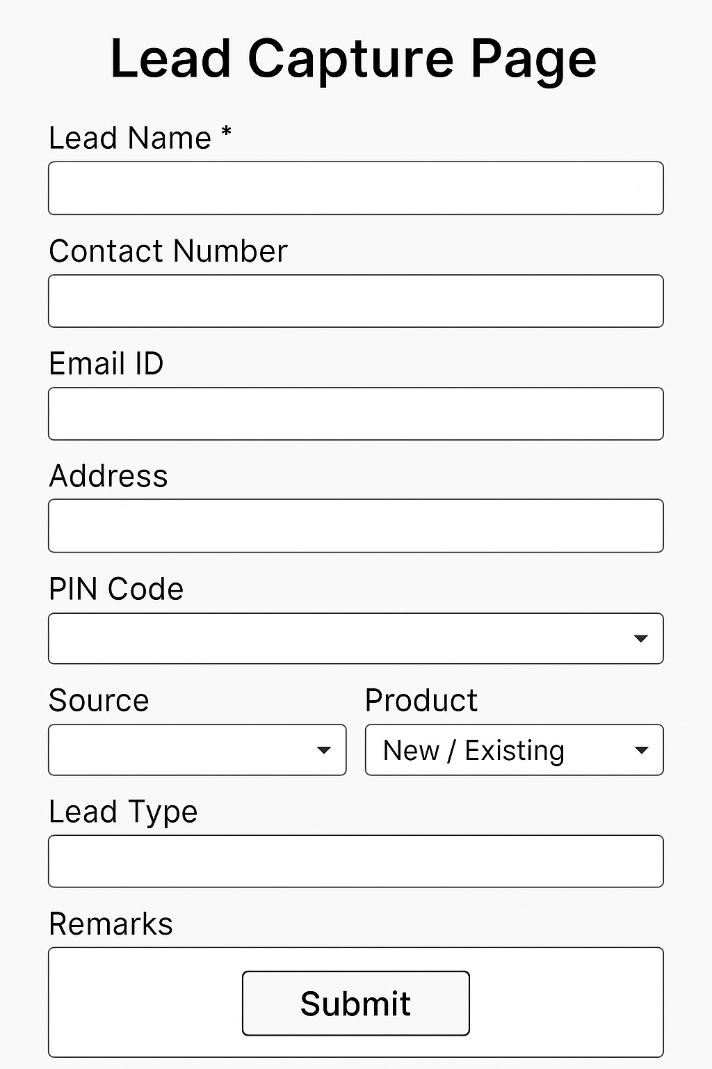

  - Lead Assignment Page
- Fields: Based on the details given by customer in Lead Capture Page, the following details should be auto-populated and saved in database.
  - Lead ID
  - Assigned Agent
  - Assignment Date
  - Assignment Mode (Manual / Auto)
- Business Rules:
  - Auto-assignment based on PIN code mapping to agent’s location.
  - Manual override allowed by Sales Manager.

Wireframe for the Lead Assignment Page:
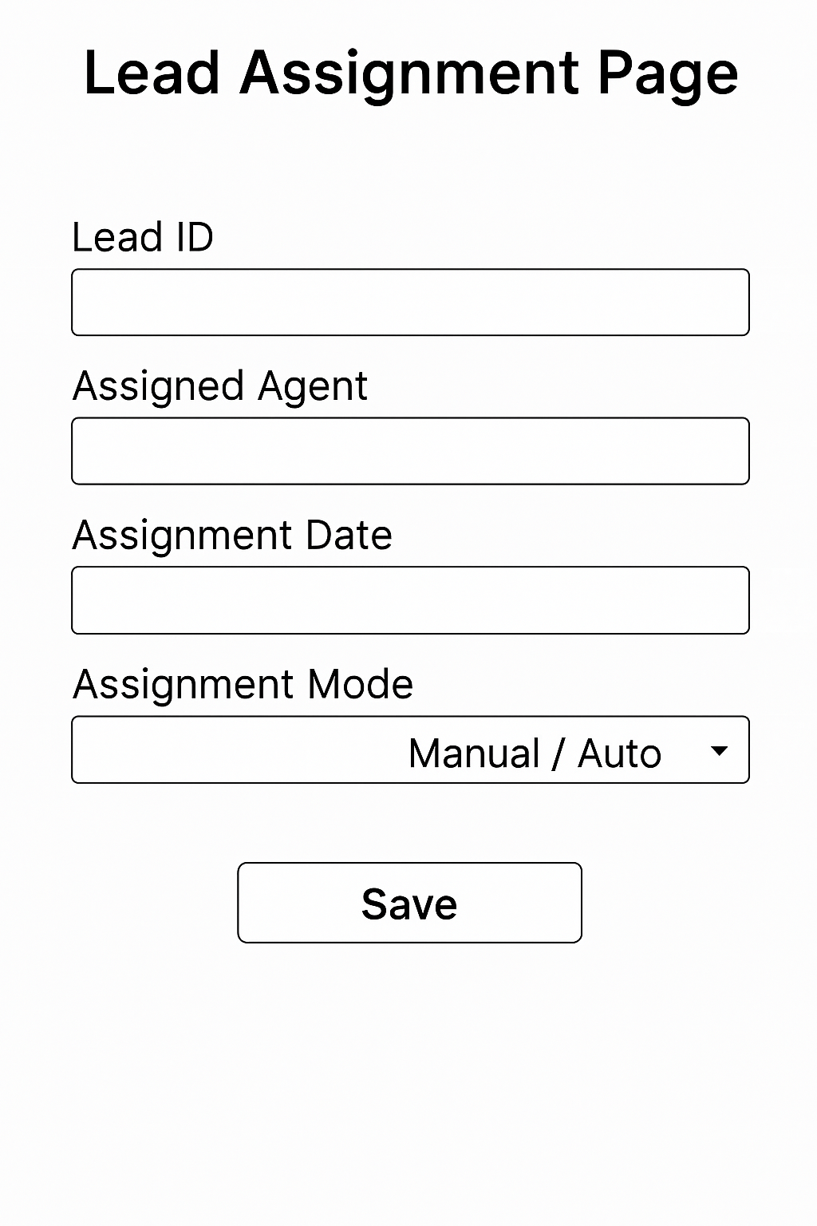
  - Lead Tracking Page
- Fields:
  - Lead ID
  - Status (New, Contacted, Follow-up, Converted, Dropped)
  - Last Interaction Date
  - Next Follow-up Date
  - Interaction Notes
Wireframe for Lead Tracking Page:
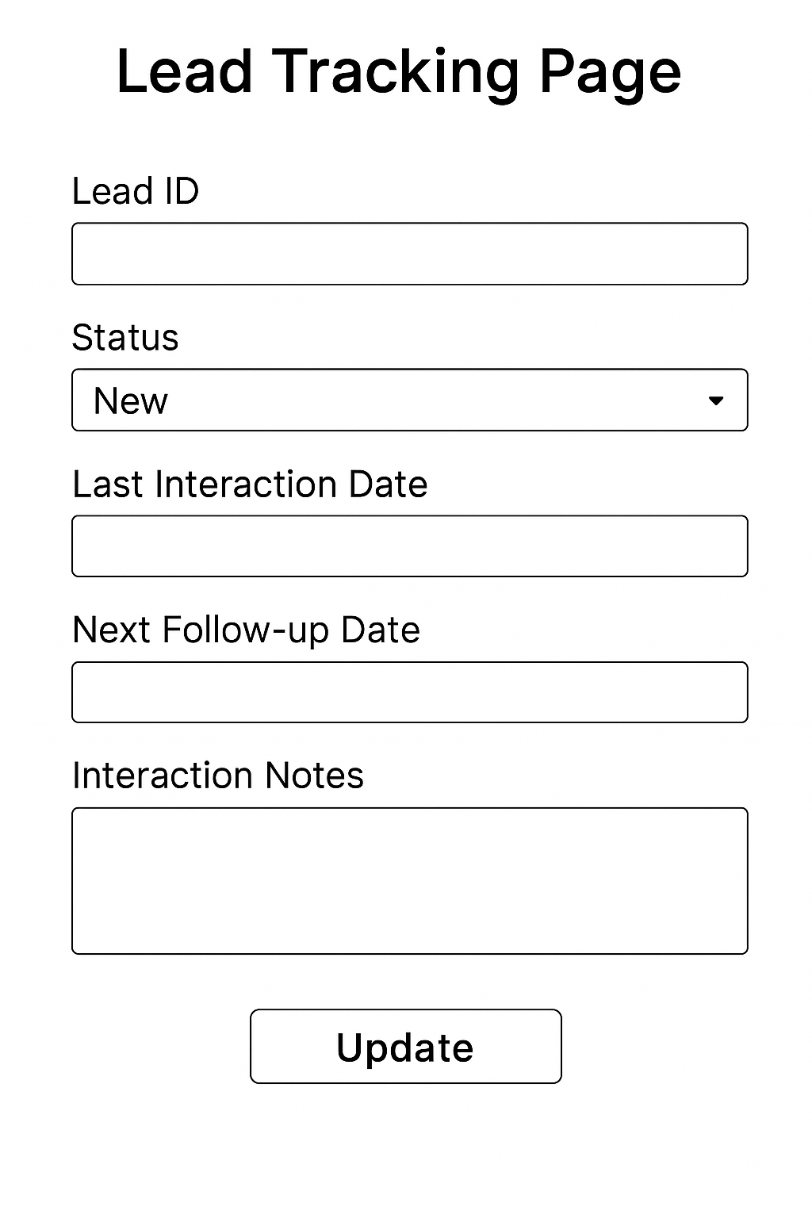
  - Lead Reallocation Page
- Fields:
  - Lead ID
  - Current Agent
  - New Agent (Dropdown based on PIN code proximity)
  - Reason for Reallocation
- Business Rules:
  - Reallocation only by Admin.
Wireframe for Lead Reallocation Page:
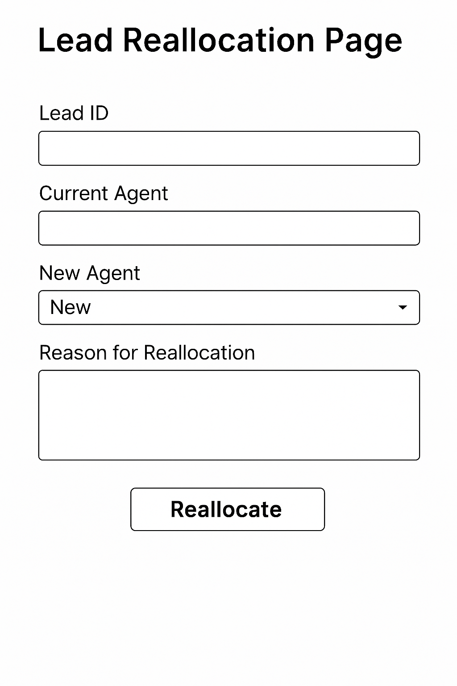
- Illustration System
  - Illustration Generation Page
- Fields:
  - Customer Name
  - Age / DOB
  - Gender
  - Sum Assured
  - Policy Term
  - Premium Payment Term
  - Product Name
  - Mobile Number
  - Email Address
Wireframe for the Illustration Generation Page:
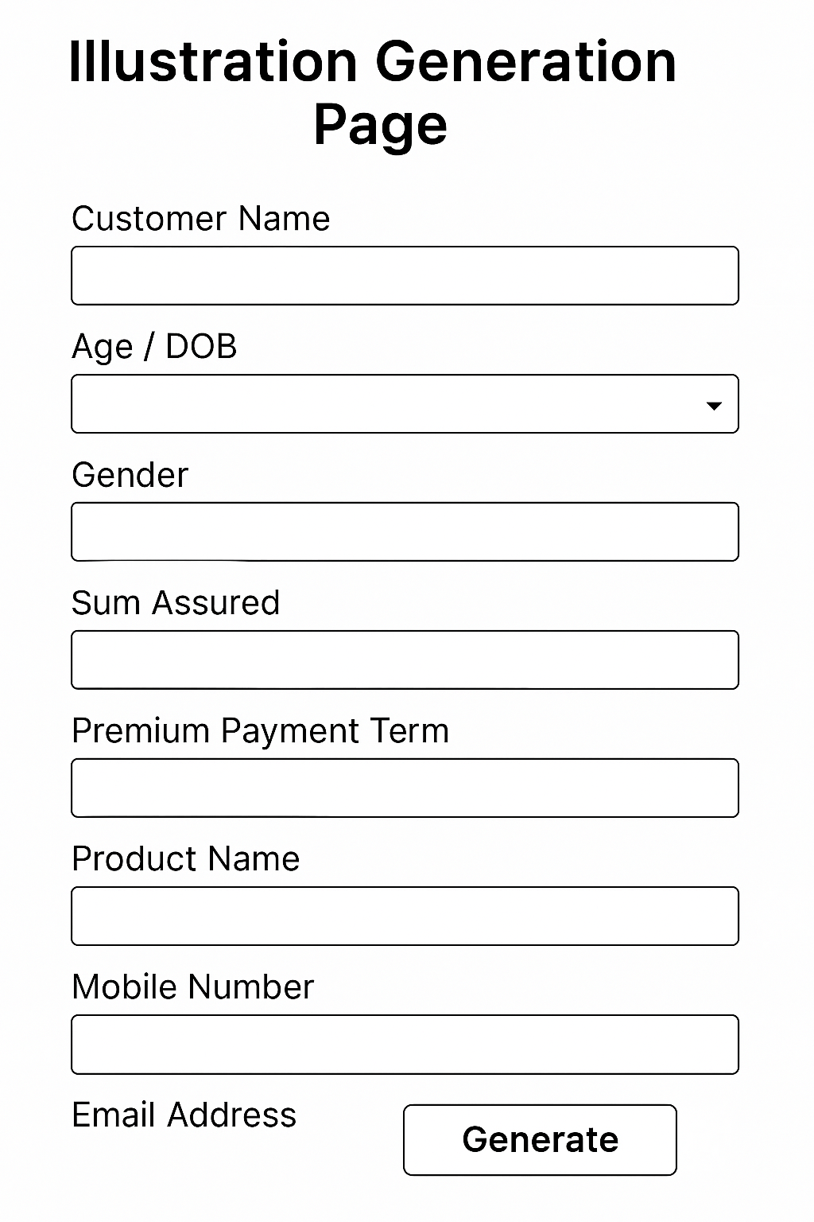

  - Benefit Illustration Page
- Fields: It should display the following output as per the details given in Illustration Generation Page:
  - Projected Maturity Value
  - Death Benefit
  - Bonus (if applicable)
  - Premium Frequency (Annual, Half-Yearly, Monthly)
  - Total Amount at Maturity = Sum Assured + Bonus
- Business Rules:
  - Total Amount to be Paid at Maturity must be displayed clearly for each product.
  - Illustration must be generated as PDF.
  - Option to proceed to policy creation should be available at the end of the illustration (button: “Proceed to Policy Creation”).
Wireframe for the Benefit Illustration Page:
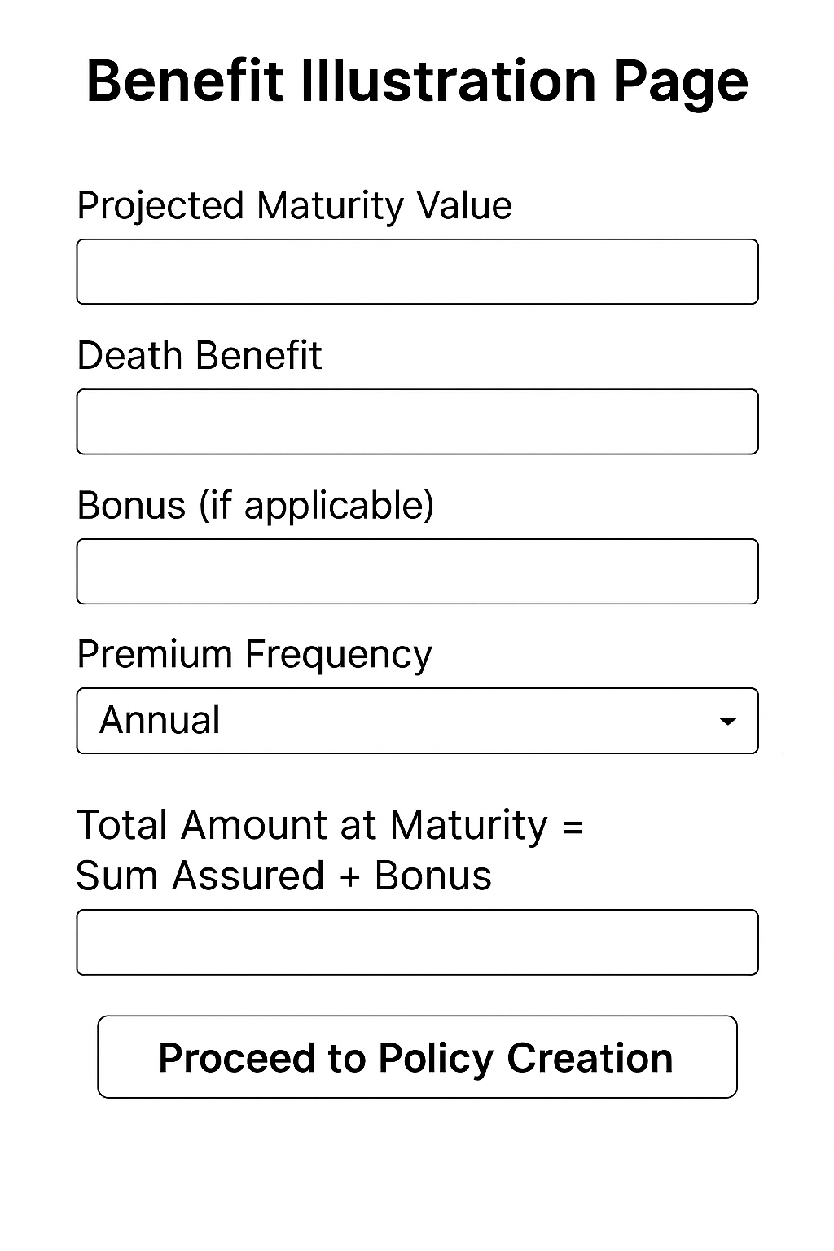

  - Illustration Configuration Page (Admin)
- Fields:
  - Product Name
  - Calculation Formula (editable)
  - Bonus Rate
  - Mortality Charges
  - Admin Charges
- Business Rules:
  - Only Admin can edit.
Wireframe for Illustration Configuration Page:
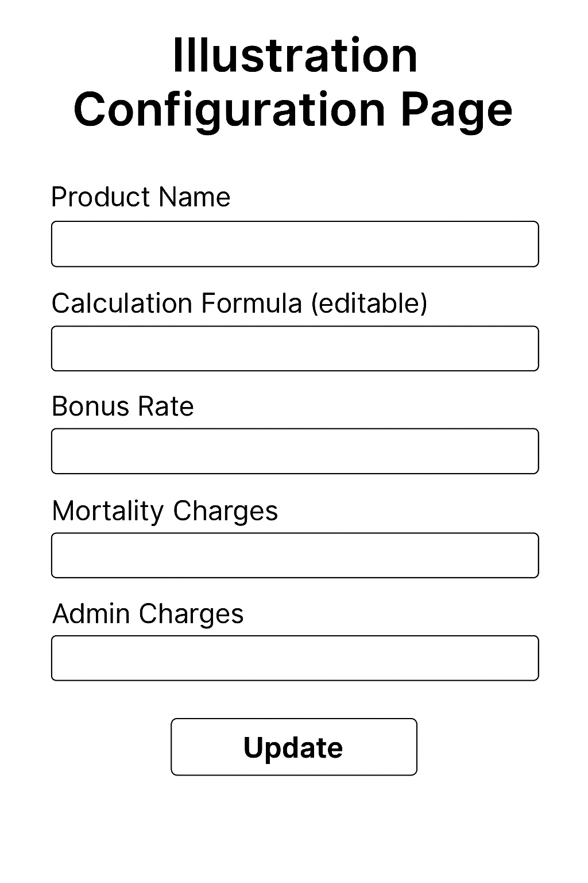

6. Process Flows/ Use Cases/ UML Diagrams
- UML Diagram for Lead Management Process:
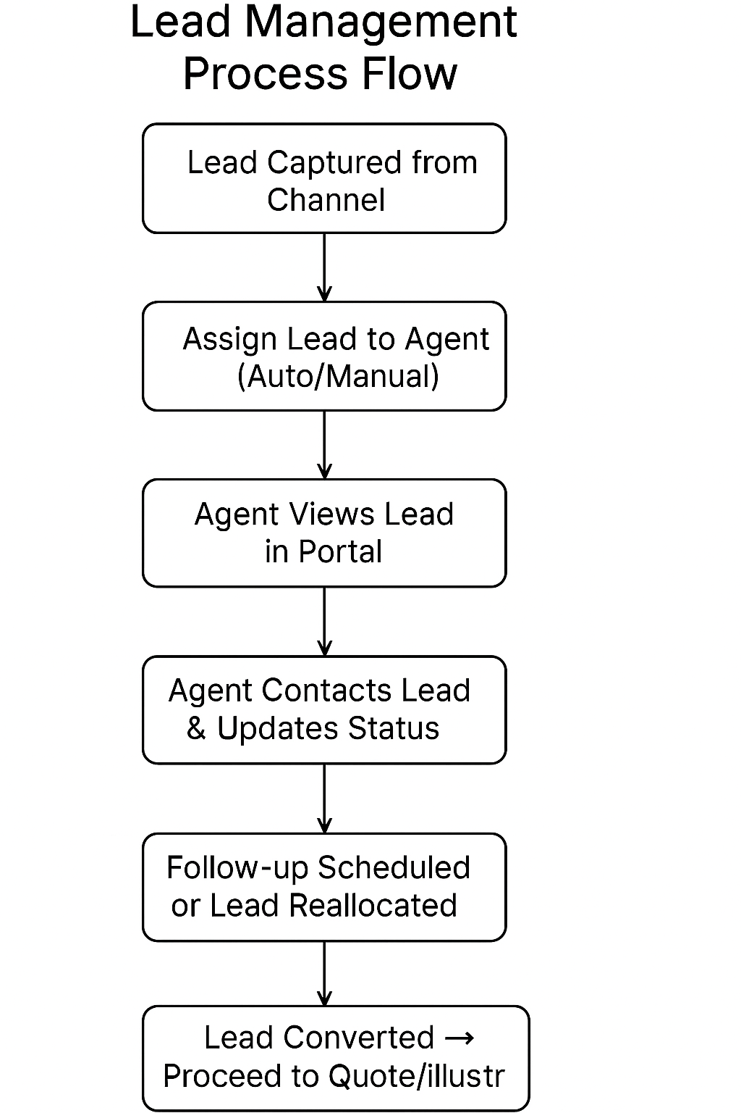
- UML Diagram for Illustration System Process:

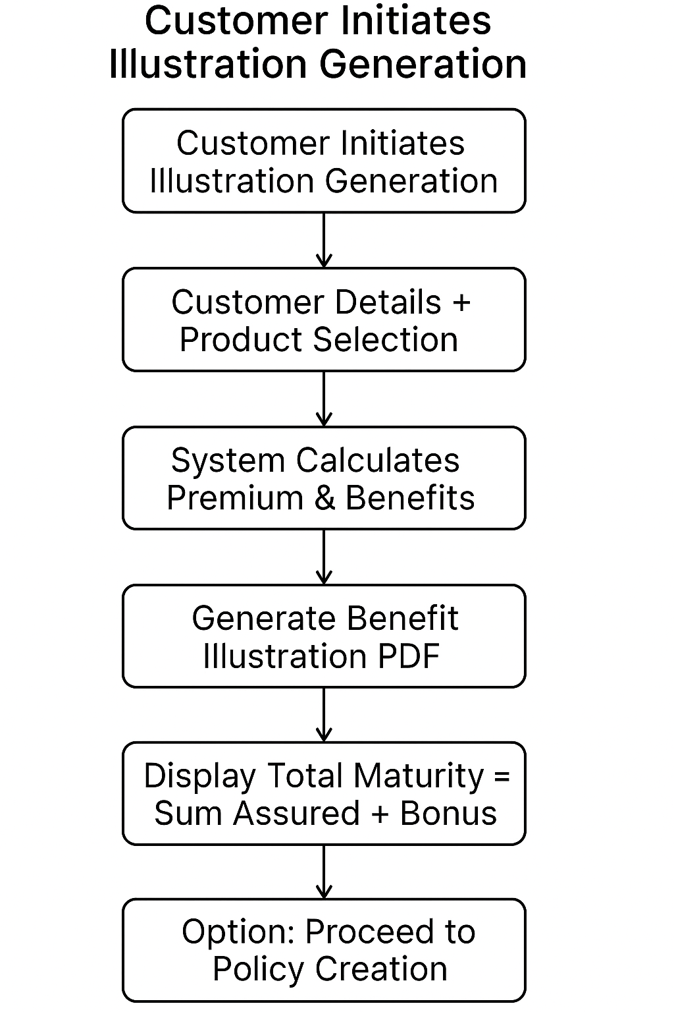

7. Appendices
The Following Documents attached below can be used.

